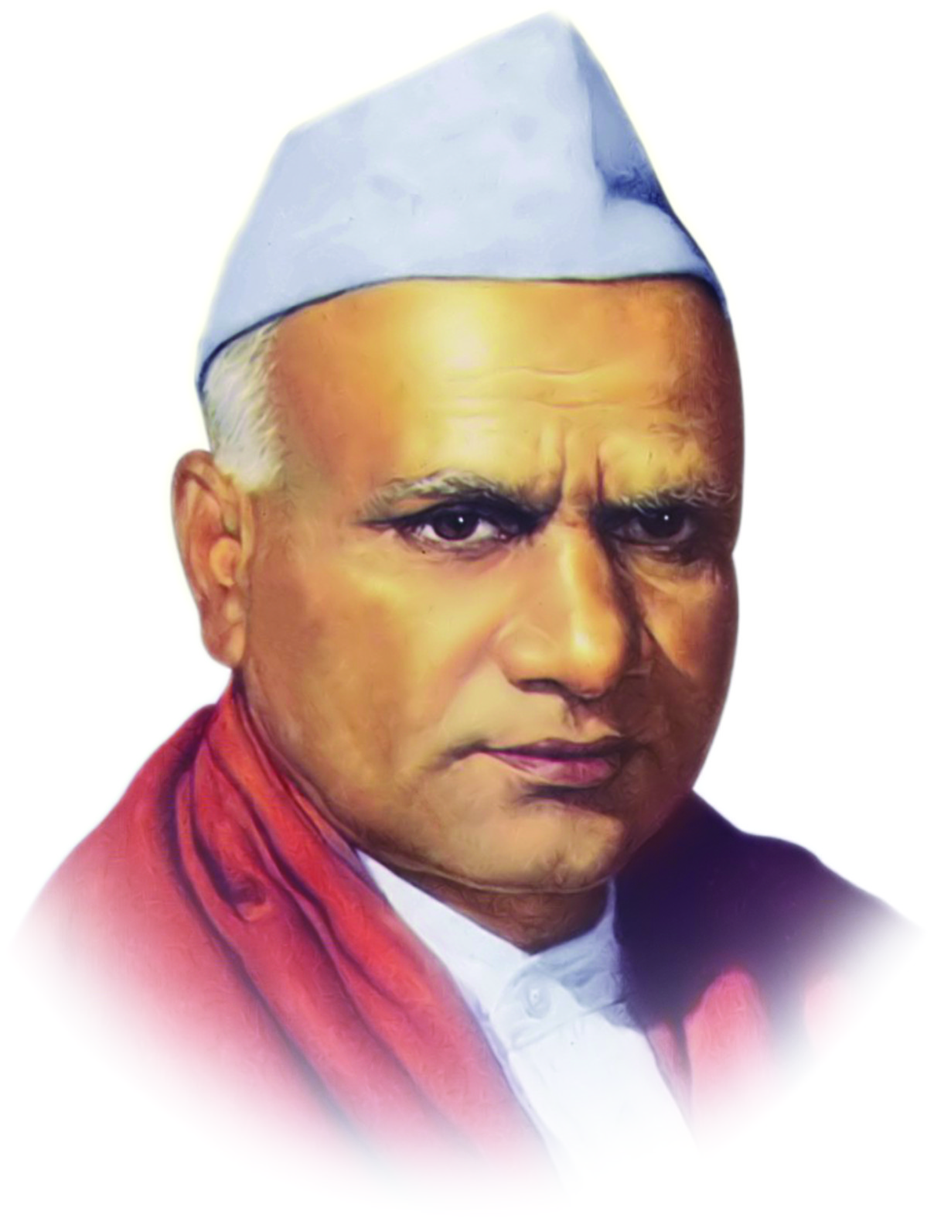
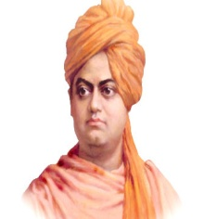
‘ज्ञान विज्ञान आणि सुसंस्कार यांसाठी शिक्षणप्रसार’
- शिक्षणमहर्षी डॉ.बापूजी साळुंखे
श्री स्वामी विवेकानंद शिक्षण संस्था, कोल्हापूर संचलित
श्रीमती आक्काताई रामगोंडा पाटील कन्या महाविद्यालय, इचलकरंजी

DEPARTMENT OF HINDI TIME-TABLE -2024-25
TIME | Class | Monday | Tuesday | Wednesday | Thursday | Friday | Saturday
I  8.00 To 8.50 | B.Com I
I  8.00 To 8.50 | B.A I |  |  | S.K Indi
I  8.00 To 8.50 | B.A II |  |  |  |  | S K Indi
I  8.00 To 8.50 | B.A III | Dr. Naik | Dr. Naik | Dr. Naik | S K Indi | English | S.K Indi
II  8.50 To 9.40 | B.Com I |  |  |  | Dr. Naik
II  8.50 To 9.40 | B.A I |  |  |  | S.K Indi
II  8.50 To 9.40 | B.A II |  |  |  |  |  | S K Indi
II  8.50 To 9.40 | B.A III | Dr.Naik | S K Indi | Dr.Naik | English | S K Indi | Dr.Naik
III  9.40 To 10.32 | B.Com I |  |  |  |  |  | Dr.Naik
III  9.40 To 10.32 | B.A I |  | SEC |  |  | S.K Indi
III  9.40 To 10.32 | B.A II | Dr. Naik | English
III  9.40 To 10.32 | B.A III | S.K Indi | English | S.K Indi | S.K Indi | Dr.Naik | S.K Indi
IV  10.45 To 11.35 | B.Com I
IV  10.45 To 11.35 | B.A.1 |  |  | SEC |  |  | S.K Indi
IV  10.45 To 11.35 | B.A II |  | Dr. Naik
IV  10.45 To 11.35 | B.A III | English | S.K Indi | Dr. Naik | Dr.Naik | Dr.Naik | Dr.Naik
V  11.35 To 12.25 | B.A I/ B.Com I | Culcharal
V  11.35 To 12.25 | B.A II |  |  | Dr. Naik
V  11.35 To 12.25 | B.A III
VI  12.25 To 1.15 | B.A I/ B.Com I |  |  | Culcharal
VI  12.25 To 1.15 | B.A II |  |  |  | S.K Indi
VI  12.25 To 1.15 | B.A III
VI  12.25 To 1.15 | B.A II |  |  |  |  | Dr.Naik
VIII  2.00 To 2.50 | B.A II |  |  |  |  |  | S.K Indi

